Task 0109724 – TFL FTP Solution 4210

TMA Inspection files need to be transferred from the FTP site down to the database for upload into exor.

This document covers the first part of the solution – FTP site to database server.

Files shipped –

* **0109724_install.sql** – Installation file - $3.0
  + **Create_job.sql** – Create Job script - $3.0
  + **X_tfl_tma_ftp.pkh** – Job scheduling wrapper package - $3.0
  + **X_tfl_tma_ftp.pkw** – Job scheduling wrapper package - $3.0

By default, the process will run at 12:00pm (midday) everyday of the week, moving the files from the FTP site (specified during installation) and moved to the database directory TMA_INSP_IMPORT_DIRECTORY on the server (as used by TMA).

This interval however can be changed once the job is migrated in as a Highways Process.

There are details later in this document for customisation.

Installation of patch

Unzip the 0109724.zip file into a folder, such as C:\0109724.

Start SQLPLUS, using this folder as the “Start In” and type the following, and press Return -

* + **Start 0109724_install.sql**

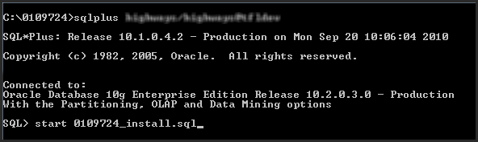

The installation process will run, and you will be prompted for the following information –

* **ENTER THE IP ADDRESS OF THE FTP SITE :**
  + The IP Address of the FTP site you wish to move files from (i.e. 192.168.xx.xx). This may work with a hostname, however the hostname needs to be resolvable from the database server.
* **ENTER THE INCOMING FOLDER ON THE FTP SITE :**
  + The folder on the FTP site which holds the TMA Inspection files (i.e. /incoming/tma/insp).
* **ENTER THE FTP USERNAME :**
  + The username of the FTP site.
* **ENTER THE FTP PASSWORD :**
  + The password of the FTP site – please note, the input is hidden so you will not see any feedback on the screen.
* **ENTER THE FTP PORT :**
  + The default port for FTP connections is usually 21.

Once the information has been entered, please check the logfile (0109724_install.log) for any errors.

Scheduled Job

Once the installation script has run and the log file as been checked, make sure the Job as been created –

SELECT owner, job_name, job_creator, job_action, start_date, repeat_interval

, last_start_date, last_run_duration, next_run_date

FROM all_scheduler_jobs

WHERE job_name = 'TMA_INSP_FTP';

This will show the job (TMA_INSP_FTP) which will execute the packaged procedure () to perform the moving of the files from FTP Site to Database server.





It will show the

* OWNER - i.e. the Highways owner
* JOB_NAME – TMA_INSP_FTP
* JOB_ACTION – The PL/SQL packaged procedure being called.
* START_DATE – Date the job was created
* REPEAT_INTERVAL – Shipped as 12 midday
* LAST_START_DATE – Will be NULL until it runs at least once.
* LAST_RUN_DATE – Will be NULL until it runs at least once.
* NEXT_RUN_DATE – Date/Time it’s due to run.

Once the Job has executed, you can check to ensure it has run -

SELECT owner, job_name, job_creator, job_action, start_date, repeat_interval

, last_start_date, last_run_duration, next_run_date

FROM all_scheduler_jobs

WHERE job_name = 'TMA_INSP_FTP';





Log Table

After the PL/SQL has been executed, you can check the results by querying the table XTFL_FTP_LOG –

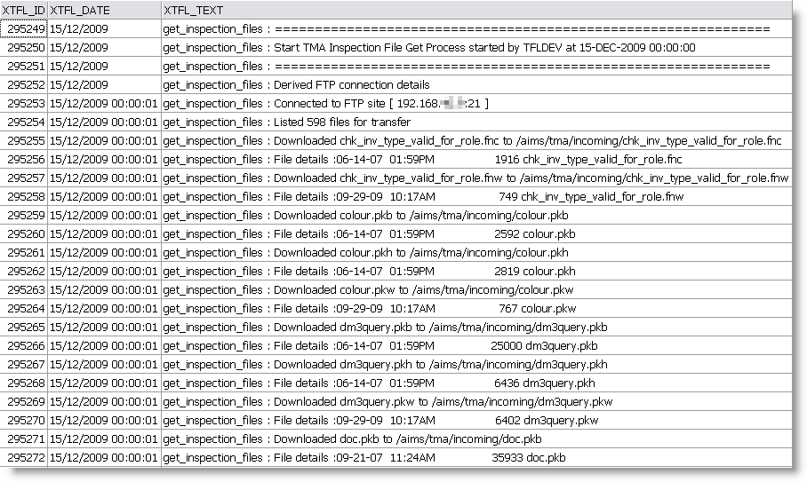

This will provide a log of all files that have been copied and deleted from the FTP site.

The data will be prefixed with “get_inspection_files : “.

Customisation – Migrate as Process

It’s recommended that the Job created should be migrated into the Process Framework for ease of maintenance and monitoring.

Once the Patch SQL script has been installed, please follow these instructions to migrate the job to a Highways Process:

1. Run “HIG2500 – Process Types” and press the “Migration Tool” button:

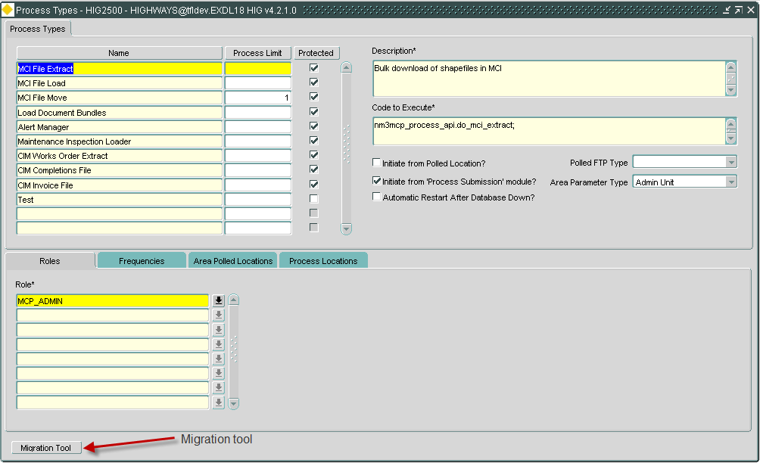

1. Filter the “Candidate Scheduler Jobs for Migration” screen on %TMA% and execute the query:

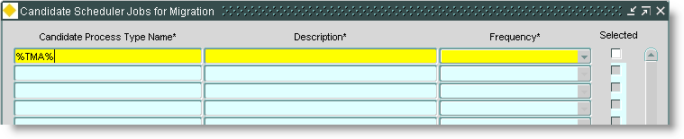

1. Select the “TMA_INSP_FTP” process, and click “OK”:

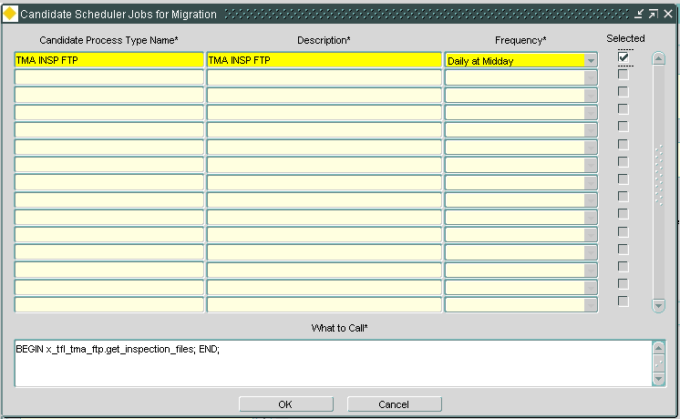

1. After the confirmation message, you will now see the TMA Inspection FTP job appear as a Process:

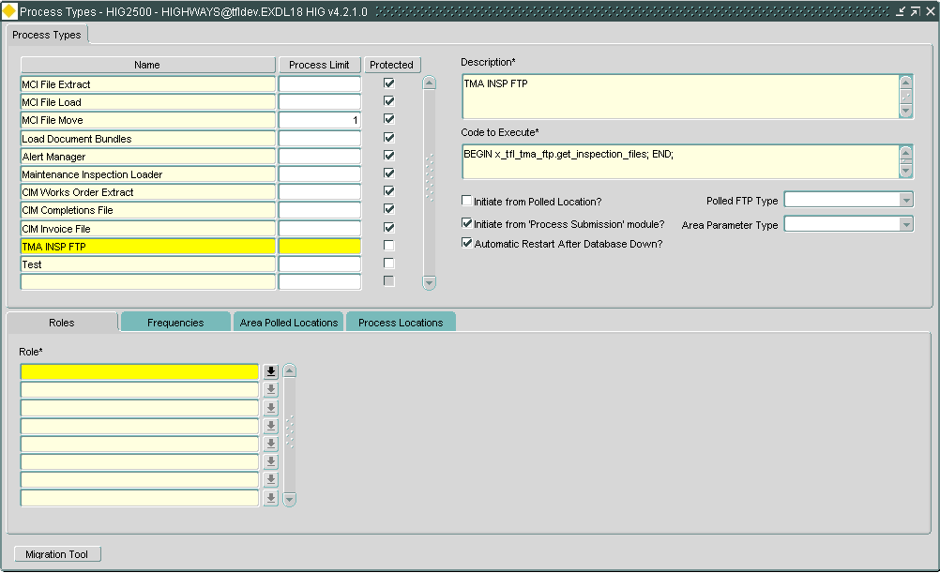

1. Add a suitable Role to the Process:

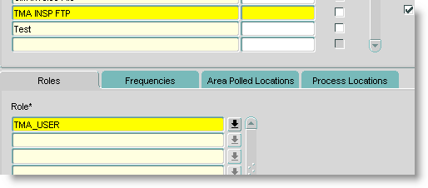

1. Add / remove desired execution Frequencies:

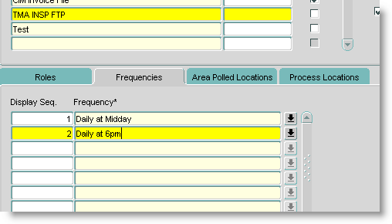

1. You then need to submit this Process Type using “HIG2510 – Submit a Process” module:

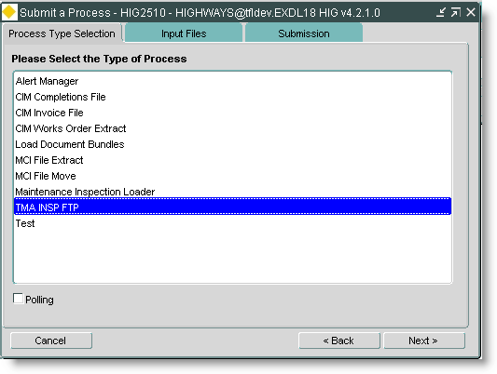

1. Give the Process a sensible name, select the desired Frequency and submit the Process by clicking “Finish” button:

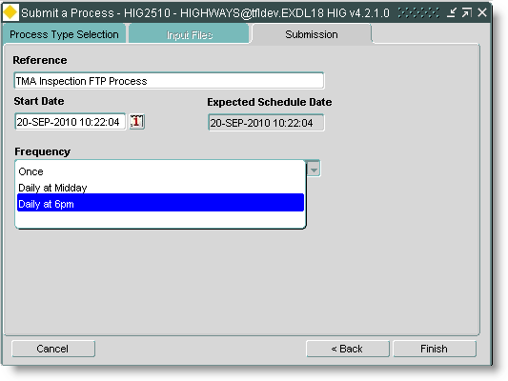

1. You can them Monitor the Process by using “HIG2520 – Process Monitor”.